**DAILY ONLINE ACTIVITIES SUMMARY**

|  |  |  |  |  |  |  |  |  |
| --- | --- | --- | --- | --- | --- | --- | --- | --- |
| **Date:** | **13/06/2020** | | | | | **Name:** | **NIKHIL KUMAR** | |
| **Sem & Sec** | **4thSEM. & ‘B’ SEC.** | | | | | **USN:** | **4AL19CS400** | |
| **Online Test Summary** | | | | | | | | |
| **Subject 1** | | **DATA COMMUNICATION** | | | | | | |
| **Max. Marks(DC)** | | **30** | | **Score** | | | **24** | |
| **Certification Course Summary** | | | | | | | | |
| **Course** | **Introduction to cyber security** | | | | | | | |
| **Certificate Provider** | | | **Greatlearning**  **Academy** | | **Duration** | | | **3.5 Hrs.** |
| **Coding Challenges** | | | | | | | | |
| **Problem Statement : Write a c program to calculate Electricity Bill**  **Problem Statement :How to find the first non repeated character of a given String using java program** | | | | | | | | |
| **Status:executed** | | | | | | | | |
| **Uploaded the report in Github** | | | | | **Yes** | | | |
| **If yes Repository name** | | | | | **1**<https://github.com/Nikhil401/java-coding/blob/master/NonRepeatedString.java>**.**  **2.** <https://github.com/Nikhil401/C-Coding/blob/master/Cacl_Elec_Bill.c> | | | |
| **Uploaded the report in slack** | | | | | **Yes** | | | |

**Online Test Summery : Subject Data Communication Test scheduled from 02:00 to 02:30 pm. The portion for the 4th IA was 1st and 2nd module and time assigned was 30 minutes and the number of questions were 30 and each contains 1 mark.**

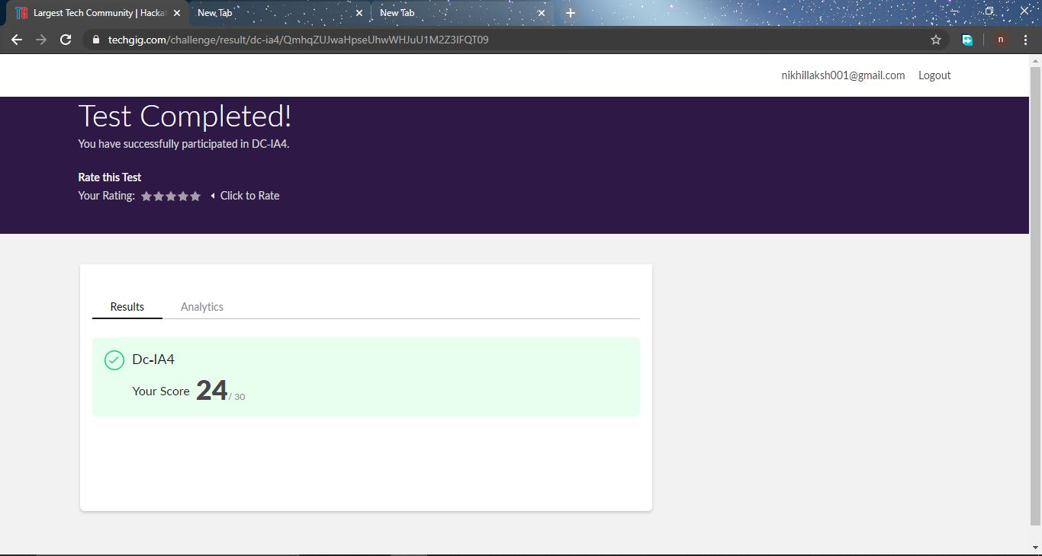

**Certification Course Summary: Today I completed the certification course “ Introduction to cyber security”**

**Snapshot is given below :**

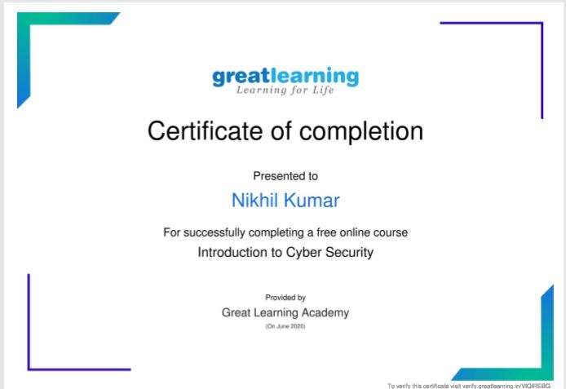

**Online Coding Summary: Today I received two program from prof . vasudev and prof. venkatesh CSE Dept. The program is mentioned above(pg.01). to my GitHub repository link and I’ve shared the snapshot below.**

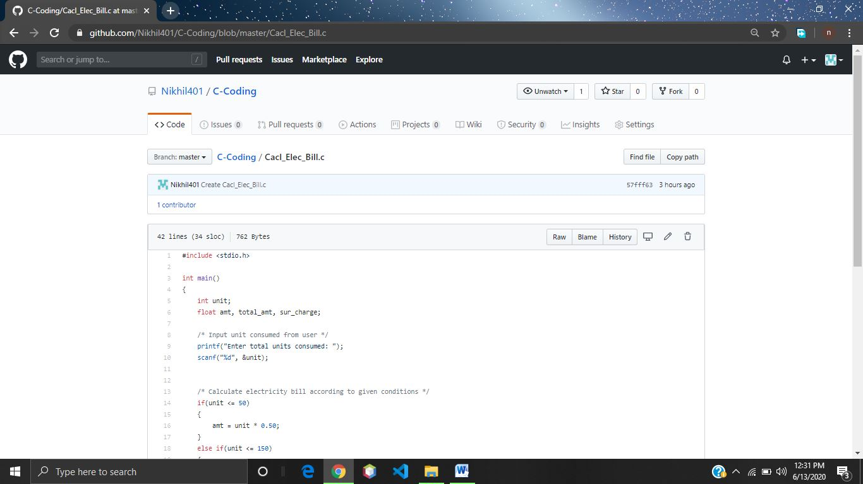

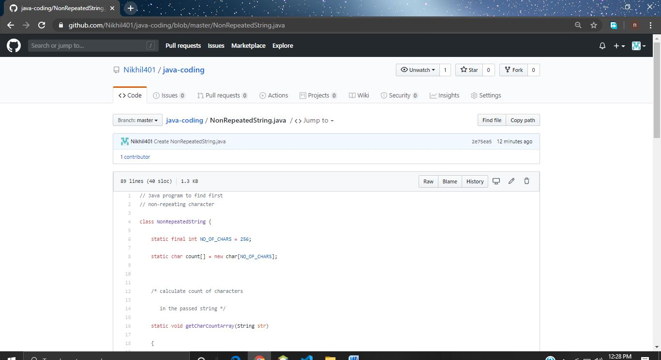 **Thank you.**